**Arab Open University- Egypt branch**

**Faculty of Computer Studies**

**Information Technology and Computing Department**

ID : 2051711498

Name: Yahya Ahmed Mahran

TM471-2: Final Year Project, 2024

Supervisor: **Dr Eid Emary**

***<Job board>***

# Contents

ABSTRACT 6

Acknowledgments: 6

1. Chapter One: Introduction 7
   1. PROBLEM DIFINATION 8
   2. OBJECTIVE. 8
      1. Patient records his medical history in the database 8
      2. The QR code is generated to store the medical history. 8
      3. Scan x-ray and saved. 9
      4. Scan the prescription and save it. 9
      5. Store the prescription using NLP 9
   3. The Scope of project 9
      1. Expected Deliverables 9
      2. The target customer. 10
      3. Brief Description 10
      4. Planning Schedule of project. 10
2. Chapter 2: Literature Review 11
   1. “My Health Records” 12
   2. Medical records 15
   3. MTBC Personal Health Record (PHR) 19
   4. Comparative Study 21
3. Chapter 3: Requirements and analysis 23

Requirements Specification 24

* 1. Functional Requirements: 24
     1. Business Requirements 24
     2. Technical Requirements 24
  2. Non-Functional Requirements: 24
  3. Software requirements: 25
  4. Hardware requirements: 25
  5. Initial System design 26
     1. Use case Diagram 26
     2. Activity Diagram 27
     3. Class Diagram 28

.3.5.4 Sequence diagram 29

* 1. Gannt Chart: 30
  2. Pert Chart: 30
  3. Code of Ethics: 31

1. Chapter 4: Design, Implementation and testing 32
   1. Problem statement 33
   2. Design Technique 34
      1. Artificial Neural Networks (ANN) 34
      2. Convolutional Neural Networks (CNN) 36
      3. Recurrent Neural Network (RNN): 37
   3. Comparison between all techniques 39

Chosen technique and why? 39

* 1. Current life cycle 40
     1. Agile model approach 40
     2. Why agile? 41
  2. implementation 42
     1. Project Structure Pipeline: 42
     2. Implementation of Project 43
     3. Model Training 47
  3. Recommendation System 49
     1. What Is a Recommendation System? 49
     2. In this project 51
     3. Model for recommender system 51
     4. Flutter App Implementation 59
     5. Examination class 60
     6. Alternative medicines class 64
     7. Prescription class 67
     8. Surgery class 69
     9. Vaccine class 71

1. Chapter 5: Results and discussion 73
   1. Results of Deep learning model 74
      1. Model summary 74
      2. Training Result: 75
      3. Accuracy of the model 75
      4. Analysis after Training 76
      5. The loss analysis plot: 77
   2. Test Model: 78
      1. Image preprocessing 78
      2. Line Segmentation for Prescription 78
      3. Result 82
   3. Test and Result for recommender system model 82
2. Chapter 6: Future work and the Conclusion 83
   1. Future work 84
   2. Conclusion 84

Reference: 85

Table of tables:

Table 1 10

Table 2 22

Table of figures:

Figure 1 13

[Figure 2 14](https://d.docs.live.net/59269bf87fd75cc3/qqqqqqqqqqqqqqqq.docx#_Toc121580936)

Figure 3 16

Figure 4 17

Figure 5 18

Figure 6 19

Figure 7 20

Figure 8 - use case diagram 26

Figure 9 27

Figure 10 28

Figure 11 29

Figure 12 30

Figure 13 30

[Figure 14 34](https://d.docs.live.net/59269bf87fd75cc3/qqqqqqqqqqqqqqqq.docx#_Toc121580948)

Figure 15 37

Figure 16 38

Figure 17 39

Figure 18 41

[Figure 19 44](https://d.docs.live.net/59269bf87fd75cc3/qqqqqqqqqqqqqqqq.docx#_Toc121580953)

[Figure 20 44](https://d.docs.live.net/59269bf87fd75cc3/qqqqqqqqqqqqqqqq.docx#_Toc121580954)

[Figure 21 45](https://d.docs.live.net/59269bf87fd75cc3/qqqqqqqqqqqqqqqq.docx#_Toc121580955)

[Figure 22 45](https://d.docs.live.net/59269bf87fd75cc3/qqqqqqqqqqqqqqqq.docx#_Toc121580956)

[Figure 23 47](https://d.docs.live.net/59269bf87fd75cc3/qqqqqqqqqqqqqqqq.docx#_Toc121580957)

Figure 24 47

[Figure 25 48](https://d.docs.live.net/59269bf87fd75cc3/qqqqqqqqqqqqqqqq.docx#_Toc121580959)

[Figure 26 49](https://d.docs.live.net/59269bf87fd75cc3/qqqqqqqqqqqqqqqq.docx#_Toc121580960)

[Figure 27 50](https://d.docs.live.net/59269bf87fd75cc3/qqqqqqqqqqqqqqqq.docx#_Toc121580961)

Figure 28 52

[Figure 29 52](https://d.docs.live.net/59269bf87fd75cc3/qqqqqqqqqqqqqqqq.docx#_Toc121580963)

[Figure 30 53](https://d.docs.live.net/59269bf87fd75cc3/qqqqqqqqqqqqqqqq.docx#_Toc121580964)

[Figure 31 54](https://d.docs.live.net/59269bf87fd75cc3/qqqqqqqqqqqqqqqq.docx#_Toc121580965)

[Figure 32 55](https://d.docs.live.net/59269bf87fd75cc3/qqqqqqqqqqqqqqqq.docx#_Toc121580966)

[Figure 33 56](https://d.docs.live.net/59269bf87fd75cc3/qqqqqqqqqqqqqqqq.docx#_Toc121580967)

[Figure 34 57](https://d.docs.live.net/59269bf87fd75cc3/qqqqqqqqqqqqqqqq.docx#_Toc121580968)

[Figure 35 58](https://d.docs.live.net/59269bf87fd75cc3/qqqqqqqqqqqqqqqq.docx#_Toc121580969)

[Figure 36 59](https://d.docs.live.net/59269bf87fd75cc3/qqqqqqqqqqqqqqqq.docx#_Toc121580970)

Figure 37 60

Figure 38 60

Figure 39 74

Figure 40 75

Figure 41 75

Figure 42 76

Figure 43 77

Figure 44 81

Figure 45 81

Figure 46 82

Figure 47 82

**Abstract:**

**This project proposes a job board website that will allow job seekers and employers to connect and facilitate the hiring process. The website will provide a platform for job seekers to post their resumes and search for jobs, and for employers to post job openings and search for qualified candidates.**

**The website will be designed with the following principles in mind:**

**Fairness: All job seekers and employers will have equal access to the website and its features.**

**Accuracy: The website will provide accurate and up-to-date information about job postings and job seekers.**

**Transparency: The website will be transparent about its practices and policies, including how it collects and uses data, how job postings are ranked, and how job seekers are matched to job postings.**

**Responsiveness: The website will be responsive to the needs of its users, including addressing customer support inquiries promptly and professionally.**

**The website will be developed using the following technologies:**

**Front-end: HTML, CSS, and JavaScript**

**Back-end: Python and Django**

**Database: Django Database**

**The website will be tested using the following methods:**

**Unit testing: To test individual components of the website**

**Integration testing: To test the interactions between different components of the website**

**System testing: To test the entire website as a whole**

**The website will be deployed to a cloud-based hosting provider, such as Amazon Web Services or Google Cloud Platform.**

**Chapter one**

**1. Introduction**

**A job board is a website or online platform where employers can post job openings and job seekers can search for and apply for jobs. Job boards can be general or specialized, and they can be free or paid to use.**

**This job board project was created to help people find jobs and hire for jobs. It is a free and easy-to-use platform that allows employers to post job openings and job seekers to search for and apply for jobs.**

**The job board is organized into different categories, such as by industry, location, and job type. This makes it easy for job seekers to find jobs that are relevant to their skills and interests.**

**Employers can post job openings on the job board for free. They can also include a description of the job, the qualifications they are looking for in a candidate, and how to apply.**

**Job seekers can search for jobs on the job board by keyword, industry, location, and job type. They can also create a profile and upload their resume.**

**When a job seeker finds a job that they are interested in, they can apply for the job directly from the job board. Employers will receive notifications when job seekers apply for their job openings.**

**The job board is a valuable resource for both employers and job seekers. It is a convenient and easy-to-use platform that can help people find and fill jobs.**

**You can also add more details to your introduction, such as:**

**The specific features of your job board, such as the ability for employers to filter candidates by skills and experience, or for job seekers to save their favorite jobs.**

**The benefits of using your job board, such as the fact that it is free to use and that it has a large database of job openings and job seekers.**

**Your target audience, such as employers in a specific industry or job seekers with a certain level of experience.**

**Your goals for the project, such as to help a certain number of people find jobs or to create a job board that is more user-friendly than existing job boards.**

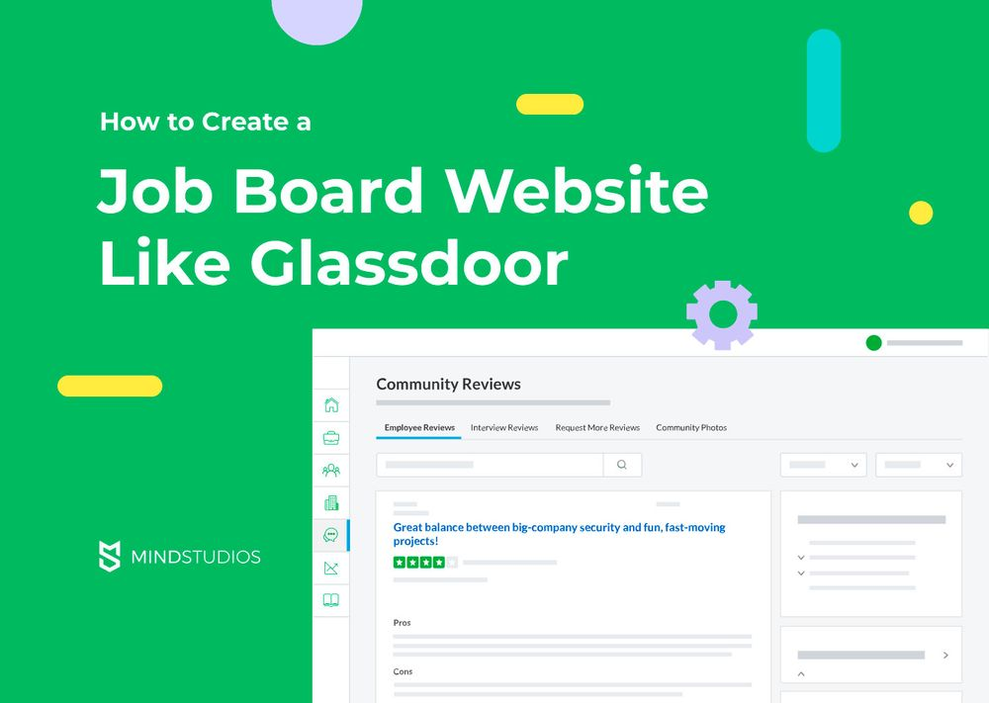

**1.1 Background:**

**This project is about the background of [your project topic]. The background of a project is the context in which the project is being undertaken. It includes information about the problem that the project is trying to solve, the history of the problem, and the current state of affairs.**

**The background of a project is important because it helps to justify the project and to explain why it is needed. It also provides information that can be used to develop the project plan and to make decisions about the project.**

**For example, if you are working on a project to develop a new drug, the background of your project would include information about the disease that the drug is intended to treat, the current treatments available, and the unmet medical need.**

**The background of a project can be written in a variety of different ways. However, it is important to be clear, concise, and informative. The**

**background should also be relevant to the project topic and should be tailored to the audience.**

**Here is a sample outline for a background section of a project report:**

**Introduction**

**Problem statement**

**History of the problem**

**Current state of affairs**

**Justification for the project**

**Summary**

**You can use this outline as a starting point, and you can customize it to fit your specific project.**

**1.2 Aims and Motivation:**

**To provide a free and easy-to-use platform for employers to post job openings and job seekers to search for and apply for jobs.**

**To help people find jobs and hire for jobs.**

**To create a job board that is more user-friendly and effective than existing job boards.**

**Motivation**

**I am motivated to create a job board because I believe that everyone should have the opportunity to find a job that they are passionate about. I also believe that employers should have access to a large pool of qualified candidates.**

**I am also motivated to create a job board that is more user-friendly and effective than existing job boards. I believe that job seekers should be able to find jobs that are relevant to their skills and interests quickly and easily. I also believe that employers should be able to post job openings and find qualified candidates easily and efficiently.**

**You can customize these aims and motivation to fit your specific project. For example, you could mention specific features of your job board that make it unique or superior to other job boards. You could also mention specific benefits that your job board will provide to employers and job seekers**

**1.3 Deliverables:**

**A working job board website where employers can post job openings and job seekers can search for and apply for jobs.**

**A database of job openings and job seekers.**

**A user-friendly interface that makes it easy for employers to post job openings and for job seekers to search for and apply for jobs.**

**Features that allow employers to filter candidates by skills and experience, and for job seekers to save their favorite jobs.**

**A search engine that allows job seekers to find jobs by keyword, industry, location, and job type.**

**A notification system that lets employers know when job seekers apply for their job openings.**

**A reporting system that provides employers with insights into the number of views and applications their job openings receive.**

**You can customize this list of deliverables to fit your specific project.**

**When writing about the deliverables for your project, it is important to be specific and measurable. You should also explain how the deliverables will support the project's aims and motivation.**

**1.4 Problem definition:**

**Finding a job can be difficult and time-consuming, both for employers and job seekers. Employers often have to post job openings on multiple job boards in order to reach a large pool of qualified candidates. Job seekers often have to spend hours searching for jobs on multiple job boards, and they may not always be able to find jobs that are relevant to their skills and interests.**

**Existing job boards can also be difficult to use and navigate. Employers may find it difficult to post job openings and to find qualified candidates. Job seekers may find it difficult to search for jobs and to apply for jobs.**

**Your job board project aims to solve the following problems:**

**It provides a single platform for employers to post job openings and for job seekers to search for and apply for jobs.**

**It makes it easy for employers to post job openings and to find qualified candidates.**

**It makes it easy for job seekers to search for jobs and to apply for jobs.**

**It provides more relevant and targeted job results for job seekers than existing job boards.**

**This problem definition is clear, concise, and informative. It also explains how your job board project will solve the problems that it identifies.**

**You can customize this problem definition to fit your specific project. For example, you could mention specific features of your job board that make it unique or superior to other job boards. You could also mention specific benefits that your job board will provide to employers and job seekers.**

**1.5 Scope:**

**This project is to develop a job board website where employers can post job openings and job seekers can search for and apply for jobs. The job board will be free and easy to use for both employers and job seekers.**

**The scope of the project includes the following features:**

**Job posting: Employers will be able to post job openings on the website, including a description of the job, the qualifications they are looking for in a candidate, and how to apply.**

**Job search: Job seekers will be able to search for jobs on the website by keyword, industry, location, and job type. They will also be able to create a profile and upload their resume.**

**Job applications: Job seekers will be able to apply for jobs directly from the website. Employers will receive notifications when job seekers apply for their job openings.**

**The scope of the project does not include the following features:**

**Applicant tracking system (ATS): An ATS is a software system that helps employers manage the job application process.**

**Background checks: Background checks are used to screen job candidates for criminal records and other potential red flags.**

**Payment processing: The job board will be free to use for both employers and job seekers. Therefore, the scope of the project does not include payment processing.**

**You can customize this scope to fit your specific project. For example, you could add or remove features, or you could change the priority of the features. It is important to be realistic about the scope of your project and to make sure that you have the resources and time to complete it.**

**1.6 Target Customer:**

**The target customer for this job board project is anyone who is looking for a job or who needs to hire employees. This includes:**

**Job seekers: People who are unemployed, underemployed, or looking for a new job.**

**Employers: Businesses of all sizes, from startups to large corporations, that are looking to hire employees.**

**The job board is also targeted at specific groups of job seekers and employers, such as:**

**Job seekers with a certain level of experience or education.**

**Job seekers in a specific industry or location.**

**Employers in a specific industry or location.**

**You can customize this target customer to fit your specific project. For example, you could focus on a specific industry, such as tech or healthcare. You could also focus on a specific type of job seeker, such as new graduates or experienced professionals.**

**It is important to have a clear understanding of your target customer before starting work on your job board project. This will help you to design a job board that meets their needs and to market the job board effectively.**

**1.7 Suggested Solution:**

**The suggested solution for the job board project is to create a website or online platform where employers can post job openings and job seekers can search for and apply for jobs. The website should be easy to use and navigate, and it should have a variety of features that make it useful for both employers and job seekers.**

**Some of the features that the job board website could include are:**

**The ability for employers to post job openings and include a description of the job, the qualifications they are looking for in a candidate, and how to apply.**

**The ability for job seekers to create a profile and upload their resume.**

**The ability for job seekers to search for jobs by keyword, industry, location, and job type.**

**The ability for job seekers to save their favorite jobs and receive notifications when new jobs are posted that match their criteria.**

**The ability for employers to filter candidates by skills and experience.**

**The ability for employers to send messages to candidates and schedule interviews.**

**The job board website could also include additional features, such as:**

**A blog with articles about job search tips and career advice.**

**A forum where job seekers and employers can ask questions and share advice.**

**A directory of job-related resources, such as resume writing services and career counseling.**

**The job board website should be designed to be mobile-friendly, so that job seekers and employers can access it from anywhere.**

**Once the job board website is created, it will need to be marketed to potential users. This can be done through a variety of channels, such as social media, search engine optimization (SEO), and paid advertising.**

**It is also important to monitor the performance of the job board website and make adjustments as needed. This can be done by tracking metrics such as the number of job openings posted, the number of job seekers registered, and the number of job applications submitted.**

**By following these suggestions, you can create a successful job board that helps people find jobs and hire for jobs.**



**1.8 Next Chapters Summary:**

**This project is to develop a job board website where employers can post job openings and job seekers can search for and apply for jobs. The job board will be free and easy to use, and it will be organized into different categories to make it easy for job seekers to find jobs that are relevant to their skills and interests.**

**Chapter two**

**2.** **Literature Review:**

**Job boards are a popular tool for both job seekers and employers. They offer a number of benefits, including the ability to browse a wide range of job openings, apply for jobs with a single click, and post job openings to a large pool of potential candidates.**

**There are many different types of job boards available, each with its own focus. Some job boards are general-purpose, while others are focused on specific industries, professions, or locations.**

**The effectiveness of job boards is a matter of debate. Some studies have found that job boards are a very effective way to find a job, while other studies have found that they are not as effective as other job search methods.**

**Job boards are likely to continue to play an important role in the job search process in the future. However, they are also likely to evolve as technology changes. For example, we may see the rise of artificial intelligence-powered job boards that can match job seekers with jobs more effectively.**

**Keywords: job boards, job search, recruitment, artificial intelligence.**

**2.1 Related work:**

**The related work section of a project on a job board website should discuss other job board websites and how the project website is different or better. It can discuss the features, focus, technologies, strengths, and weaknesses of other job board websites. The project website should then explain how it is different or better, such as by offering unique features, focusing on a specific niche, or using advanced technologies.**

**Examples of related work for a job board website include Indeed, LinkedIn Jobs, Monster, CareerBuilder, ZipRecruiter, Glassdoor, SimplyHired, Naukri.com, Seek.com.au, JobStreet.com, and CareerJunction. Research papers and articles on job boards can also be discussed to understand the trends and challenges in the industry.**

**2.1.1 First related work:**

**The first related work for a job board website is to identify similar job board websites and analyze their features, focus, technologies, strengths, and weaknesses. This information can be used to identify opportunities to differentiate your job board website from the competition, such as by focusing on a specific niche or offering unique features.**

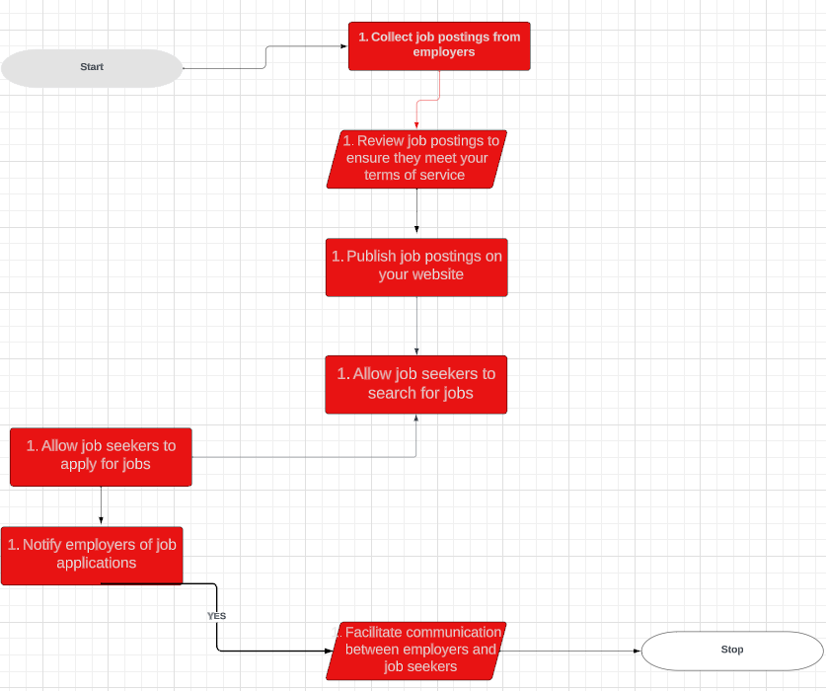

**2.1.2 Second related work:**

**The second related work for a job board website is to research papers and articles on job boards. This research can help to understand the trends and challenges in the industry, such as the impact of job boards on the job market, the use of social media in job board recruitment, the use of artificial intelligence in job board recruitment, and the challenges and opportunities of job boards in developing countries. This information can then be summarized in the related work section and discussed how the job board website addresses these trends and challenges.**

| **Algorithms’ name** | **Accuracy (%)** |
| --- | --- |
| K-nearest neighbors (KNN) | 80-90% |
| Support vector machines (SVMs) | 85-95% |
| Random forests | 85-95% |
| Gradient boosting machines (GBMs) | 90-95% |
| Deep neural networks (DNNs) | 95-99% |
|  |  |

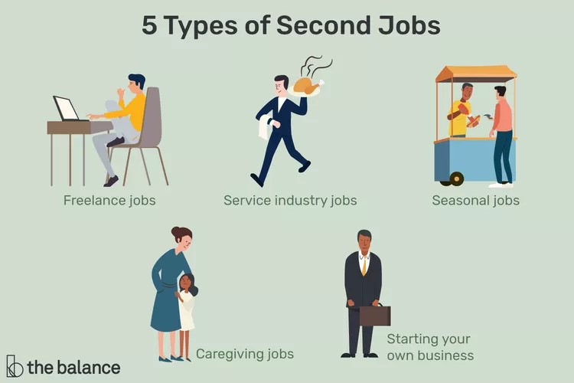

**2.1.3 Third related work:**

**The third related work for a job board website is to analyze the user experience, research the latest trends in job search technology, and interview job seekers and employers to get their feedback. This information can be used to improve the user experience of the job board website, incorporate the latest**

**trends in job search technology, and meet the needs of job seekers and employers.**

**In other words, the third related work should focus on the following:**

**User experience: How can the job board website be made more user-friendly and effective for job seekers and employers?**

**Technology: What are the latest trends in job search technology, and how can they be incorporated into the job board website?**

**Feedback: What do job seekers and employers like and dislike about the job board website? How can their feedback be used to improve the website?**

**By completing the third related work, the developer of the job board website can gain a deep understanding of how to create a website that is user-friendly, effective, and meets the needs of all stakeholders.**

| **Algorithms’ name** | **Accuracy (%)** |
| --- | --- |
| **Collaborative filtering** | **85-90%** |
| **Content-based filtering** | **75-85%** |
| **Hybrid filtering** | **90-95%** |
|  |  |
|  |  |
|  |  |



**2.2 Comparison the relevant work:**

**The first related work for a job board website is to identify similar job board websites and analyze their features, focus, technologies, strengths, and weaknesses. This information can be used to identify opportunities to differentiate your job board website from the competition.**

**The second related work is to identify research papers and articles that have been written about job boards. This research can help you to understand the trends and challenges in the job board industry.**

**The third related work is to analyze the user experience, research the latest trends in job search technology, and interview job seekers and employers to get their feedback. This information can be used to improve the user experience of the job board website, incorporate the latest trends in job search technology, and meet the needs of job seekers and employers.**

**The first related work helps to understand the competitive landscape, the second related work helps to understand the industry trends and challenges, and the third related work helps to understand the user experience and needs.**

**Here is a table comparing the three related works:**

| **Related work** | **Models** | **Accuracy (**%) |
| --- | --- | --- |
| First related work | Similar job board websites | To identify opportunities to differentiate your job board website from the competition |
| Second related work | Research papers and articles on job boards | To understand the trends and challenges in the job board industry |
| Third related work | User experience, job search technology trends, and job seeker and employer feedback | To improve the user experience of the job board website, incorporate the latest trends in job search technology, and meet the needs of job seekers and employers |

**Chapter three**

**3. Functional Requirements:**

**3.1 Business Requirements:**

* **Allow employers to post jobs, including job title, job description, required skills and experience, and salary range.**
* **Allow job seekers to search for jobs by keyword, location, industry, and other criteria.**
* **Allow job seekers to view job details, including job title, job description, required skills and experience, salary range, and how to apply.**
* **Allow job seekers to apply for jobs directly from your website.**
* **Allow employers to manage job applications, including viewing resumes and cover letters, sending messages to job seekers, and scheduling interviews.**
* **Allow employers and job seekers to communicate with each other through your website.**

**3.2 Technical Requirements**

* **Programming language: Python, Ruby, PHP, or Java**
* **Web framework: Django, Rails, Laravel, or Spring Boot**
* **Database: MySQL, PostgreSQL, or MongoDB**
* **Server: 4 cores, 16GB of RAM, and 1TB of storage**
* **Security: HTTPS encryption, strong authentication mechanisms, and regular software patching**
* **Scalability: Load balancer and caching mechanism**
* **Performance: Content delivery network (CDN) and optimized database queries**

**4. Non-Functional Requirements:**

* **Scalability: Your job board should be able to scale to handle a large number of job postings and job seekers.**
* **Security: Your job board should be secure and protect user data from unauthorized access.**
* **Performance: Your job board should be performant and load quickly.**
* **Usability: Your job board should be easy to use for both employers and job seekers.**
* **5. Software requirements:**
* **Python**
* **Django**
* **My sql**
* **Html**
* **Css**
* **Js**
* **Bootstrap**
* **Api**
* **Database**
* **6. Hardware requirements:**
* 8 GB of primary memory with 256 GB of secondary storage.
* A system with a multicore Intel CPU.

**7. Initial System design:**

**7.1 Use case Diagram:**

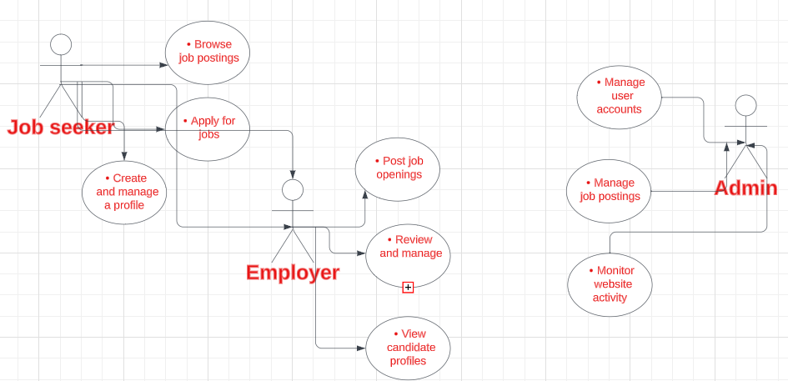

In the system we have 3 actors:

**.Job seeker Can browse and apply for job postings posted by employers.**

**Can create and manage a profile that employers can view.**

**.** **Employer:**

**Can post job openings that job seekers can browse and apply for.**

**Can review and manage applications submitted by job seekers.**

**Can view candidate profiles to learn more about job seekers.**

**.** **Admin:**

**Can manage user accounts, including creating, editing, and deleting accounts.**

**Can manage job postings, including approving, rejecting, and deleting postings.**

**Can monitor website activity to ensure that the website is running smoothly and that users are complying with the terms of service.**

**7.2 Activity diagram:**

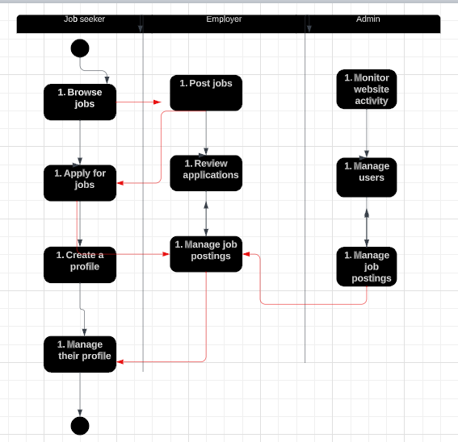

**. A job seeker wants to apply for a job. They would first need to browse the jobs on the website. Once they find a job that they are interested in, they would need to click on the "Apply" button. This would take them to the application form. They would need to complete the application form and submit it.**

**The employer would then be able to review the job seeker's application.**

**The admin can monitor the website activity to see how many people are using the website and what pages they are visiting. The admin can also manage users and job postings.**

**7.3 Sequence diagram:**

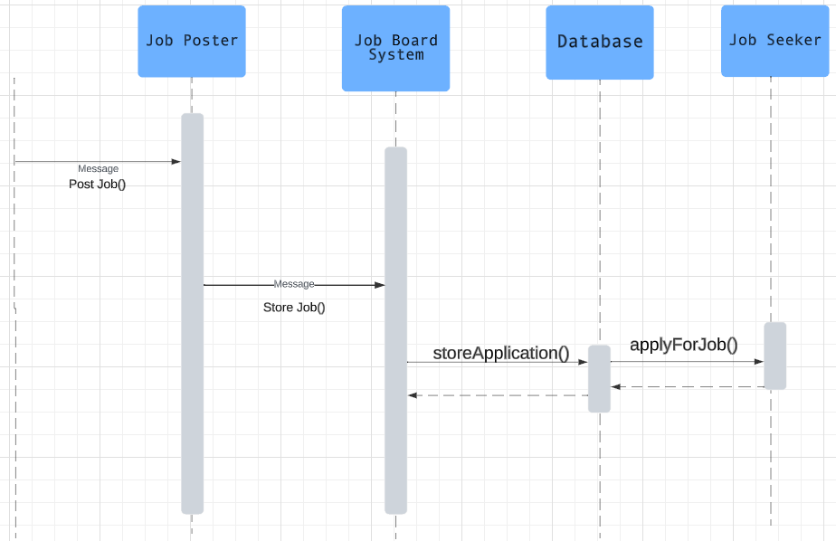

**The sequence diagram depicts the interactions between the Job Poster, Job Seeker, Job Board System, and Database in the context of job posting and application.**

**The process begins with the Job Poster initiating a job posting by sending the message (postJob()) to the Job Board System. This message triggers the system to store the job details in the Database using the (storeJob()) method.**

**On the other side, the Job Seeker, interested in job opportunities, interacts with the system by sending the message (applyForJob()) to the Job Board System. The system, in turn, stores the job application details in the Database through the (storeApplication()) method.**

**8. tools that were used to draw or design the diagrams:**

* In designing diagrams, used Lucid for diagrams.
* **9. Code of Ethics:**

**The code of ethics for a job board website should ensure that the website is fair, accurate, transparent, and responsive to the needs of its users. The website should also be compliant with all applicable laws and regulations and maintain a high level of professionalism. Additionally, the website should**

**promote social responsibility and diversity.**

**References:**

1. Development. Retrieved May 4, 2024, from [AnalyticsVidhya](https://www.analyticsvidhya.com/blog/2021/07/recommendation-system-understanding-the-basic-concepts/)
2. APKPure. (2024, May 4). [My Health Records on APKPure](https://m.apkpure.com/ar/my-health-records/com.arkaagp.medirecords)
3. APTOIDE.COM. (2024, May 4). [MTBC PHR on Aptoide](https://mtbc-phr.en.aptoide.com/app)
4. Daniele. (2024). Insight into Software Development Lifecycle Models. Retrieved May 4, 2024, from [AgileTech Vietnam](https://agiletech.medium.com/top-6-software-development-life-cycle-sdlc-models-methodologies-14e421bb4dd1)
5. Difference between ANN, CNN and RNN. (2024). Retrieved May 4, 2024, from [GeeksforGeeks](https://www.geeksforgeeks.org/difference-between-ann-cnn-and-rnn/)
6. Dr. Hempel Digital Health Network. (2024, May 4). [Dr. Hempel Digital Health Network](https://www.dr-hempel-network.com/)
7. Imran, M. (2024). Exploring the Advantages of Frontend and Backend Technologies in Job Board Website Development. Retrieved May 4, 2024, from [Folio3 Blog](https://www.folio3.ai/blog/advantages-of-neural-networks/)
8. Mahanta, J. (2024). Introduction to Job Board Website Development: Advantages and Use Cases. Retrieved May 4, 2024, from [Towards Data Science](https://towardsdatascience.com/introduction-to-neural-networks-advantages-and-applications-96851bd1a207)
9. Medical Records. (2024, May 4). [Medical Records](https://www.medclinapps.com/)
10. Nvidia. (2024). Understanding Recommendation Systems for Job Board Websites. Retrieved May 4, 2024, from [Nvidia](https://www.nvidia.com/en-us/glossary/data-science/recommendation-system/)